# Technical Spec of Shanoir Old Anonymization

During the import, the user have to click on the button “import Dicom Data” displayed by the xhtml page importFromSCP.xhtml. This action triggers the method processFullImportFromNetwork() of the java class ContextualImportSupport. processFullImportFromNetwork() perform many actions to prepare data import in shanoir PACS, described in figure 1.

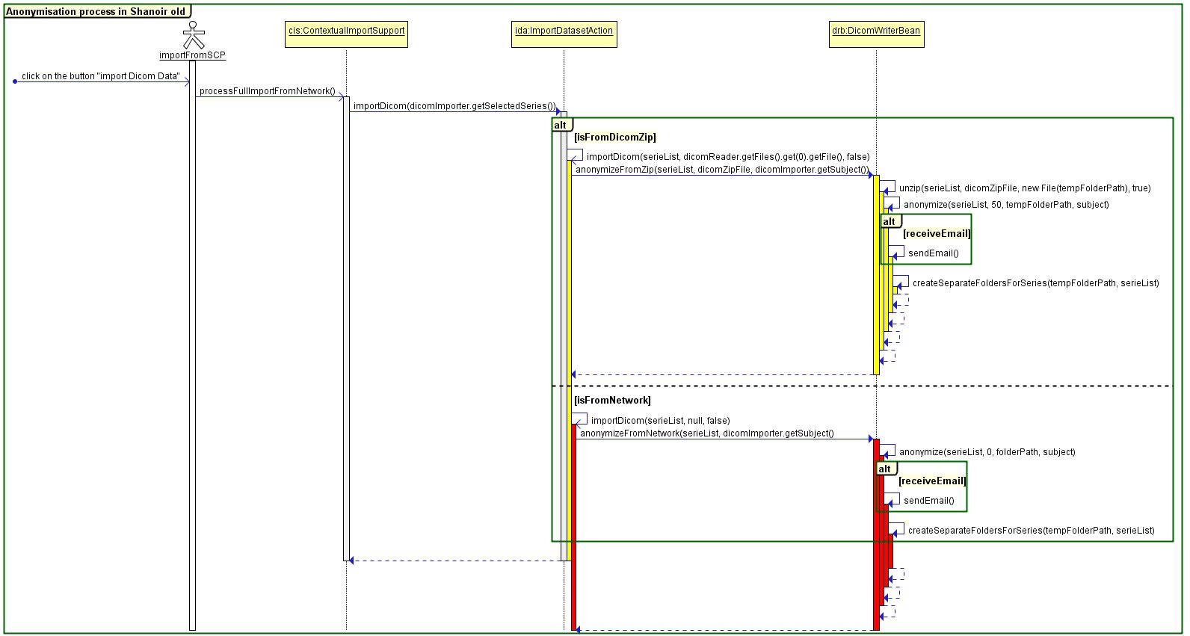

Figure 1. Anonymisation process in Shanoir old

Data anonymization is one of the actions that should be done before storing DICOMs in shanoir. The method anonymize(…) of the class DicomWriterBean.java is responsible of the anonymization process. This process is described by figure 2.

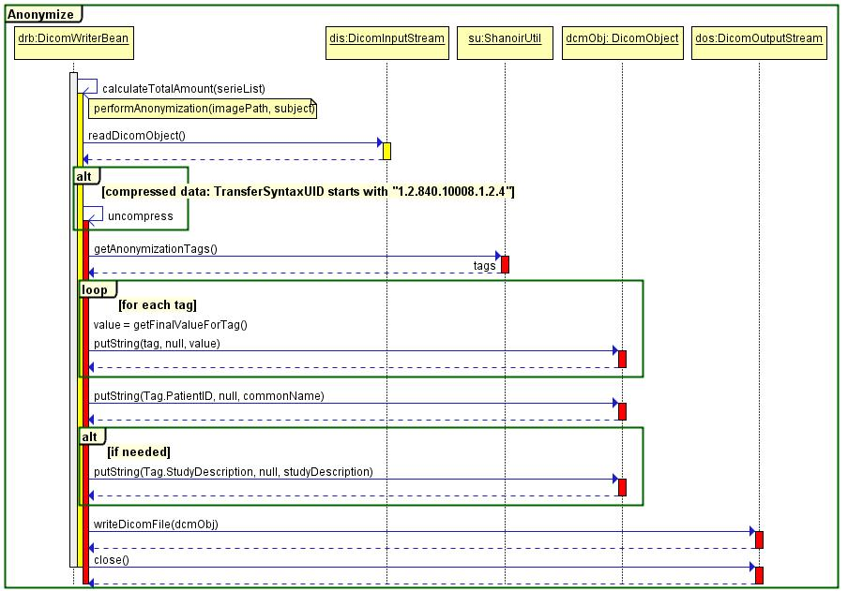

Figure 2. The anonymize method

The final value that replaces the nominative data in the DICOM tag depends on the tag anonymized. Some tags are simply deleted from the DICOM file, others are replaced by other values as described by figure 3.

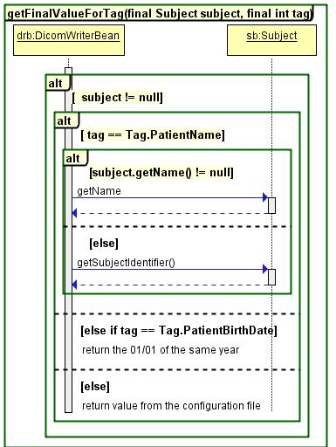

Figure3. getFinalValueForTag method: gets anonymized tag value

The list of tags to be anonymized is stored is the property file shanoir.propeties.